AI-Based Solar Panel Performance Monitoring and Fault Detection

A Project Based Learning Report Submitted in partial fulfilment of the requirements for the award of the degree

of

Bachelor of Technology
in The Department of ECE
ANALOG ELECTRONIC CIRCUIT DESIGN - 25EC 1302E

Submitted by
2510040069: Gurija Manogna
2510040038: Sathwika
2510040098: Spandana
2510040106: Nithya Sri

Under the guidance of
Dr A. Bhuvaneshwari/ Dr Sanjay / Mrs Madhavi



Department of Electronics and Communication Engineering
Koneru Lakshmaiah Education Foundation, Aziz Nagar
Aziz Nagar – 500075
FEB - 2025.
Abstract
An integrated AI-based fault detection framework combining analog signal conditioning, signal processing filtering, and Machine Learning classification for solar PV systems.

List of Figures
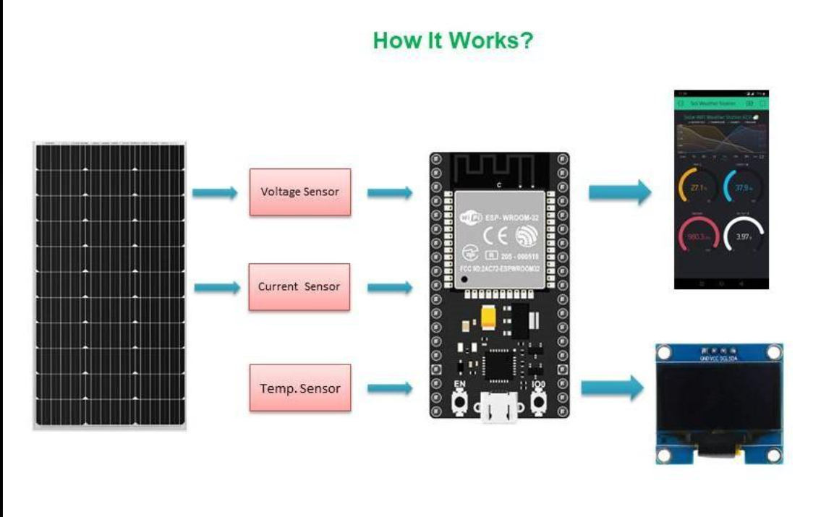

List of Tables
Table 1: Solar Panel Sensor Data
S. No. | Voltage (V) | Current (A) | Power (W) | Temperature (°C) | Irradiance (W/m²)
1 | 18.5 | 2.8 | 51.80 | 30 | 850
2 | 19.2 | 3.1 | 59.52 | 32 | 900
3 | 15.0 | 1.5 | 22.50 | 35 | 700
4 | 10.5 | 0.8 | 8.40 | 38 | 650
5 | 17.8 | 2.5 | 44.50 | 55 | 800

Table 2: Fault Detection Results
S. No. | Condition | Expected System Output
1 | Normal operation | Normal
2 | Reduced current | Possible shading or electrical fault
3 | Low voltage | Possible connection or panel fault
4 | High temperature | Overheating warning
5 | Low power output | Performance degradation warning

Table 3: Hardware Components
Component | Purpose
Solar panel | Generates electrical energy
Voltage sensor | Measures panel voltage
Current sensor | Measures panel current
Temperature sensor | Monitors panel temperature
ESP32 or Arduino | Collects sensor readings
Computer | Runs the Python monitoring program

Table 4: Software and Technologies
Technology | Purpose
Python | Main programming language
NumPy | Numerical calculations
Pandas | Data handling
Matplotlib | Graphs and visualization
Scikit-learn | Machine learning model
Signal Processing | Filters noise and extracts useful features
Analog Electronic Circuits | Sensor interfacing and signal conditioning

Table 5: Model Evaluation
Use this table when you have run the model and obtained actual evaluation results.

Metric | Meaning
Accuracy | Percentage of correct predictions
Precision | How many predicted faults were actually faults
Recall | How many actual faults were detected
F1-score | Balance between precision and recall

Table 6: Project Development Plan
Review | Work to Complete
Review 1 | Problem statement, objectives, and feasibility
Review 2 | System architecture, sensors, and ML implementation
Review 3 | Working demonstration, graphs, testing, and results

Table of Contents
Table 1: Solar Panel Sensor Data
Table 2: Fault Detection Results
Table 3: Hardware Components
Table 4: Software and Technologies
Table 5: Model Evaluation
Table 6: Project Development Plan

AI-Based Solar Panel Performance Monitoring and Fault Detection

1. INTRODUCTION
Solar energy is a renewable and environmentally friendly source of electricity. However, the performance of solar panels can decrease due to shading, dust accumulation, abnormal temperature, electrical connection problems, and other faults. These issues can reduce power generation and increase maintenance costs.
The proposed AI-Based Solar Panel Performance Monitoring and Fault Detection system monitors important solar panel parameters, including voltage, current, temperature, and solar irradiance. Signal processing techniques can be used to reduce noise in sensor readings, while machine learning algorithms analyze the collected data to identify abnormal operating conditions.
The system calculates output power using voltage and current measurements and compares the observed performance with expected operating conditions. When abnormal behavior is detected, the system generates a warning to help users identify potential faults earlier.
The project integrates Analog Electronic Circuit Design, Signal Processing, and Machine Learning into a single monitoring solution. Its objective is to improve fault identification, support preventive maintenance, and encourage efficient solar energy utilization.

Objectives
Monitor solar panel voltage, current, temperature, and irradiance.
Calculate power output and observe performance changes.
Apply signal processing to reduce measurement noise.
Use machine learning or rule-based logic to identify potential faults.
Display monitoring results and generate warnings for abnormal conditions.

2. METHODOLOGY
The proposed system follows a sequence of data acquisition, signal processing, feature extraction, fault detection, and result visualization.

2.1 System Architecture
The system consists of the following stages:
Solar Panel → Sensors → Signal Conditioning → Data Processing → Machine Learning Model → Fault Classification → Dashboard and Alerts

2.2 Data Acquisition
Voltage and current sensors collect electrical measurements from the solar panel. A temperature sensor monitors panel temperature, while an irradiance sensor or suitable measurement source estimates the sunlight intensity. A microcontroller, such as an ESP32 or Arduino, can collect the sensor readings and transfer them to a computer.

2.3 Analog Electronic Circuit Design
Sensor interfacing and signal-conditioning circuits help convert measured quantities into signals suitable for the data acquisition system. Voltage dividers, suitable current-sensing circuits, and filtering circuits may be used depending on the sensor specifications. Protection and isolation must be considered where required.

2.4 Signal Processing
Sensor readings may contain noise or sudden fluctuations. Digital filtering, such as a moving-average filter, can smooth measurements before analysis. The processed readings are used to calculate power and identify changes in the panel's operating behavior.
The output power is calculated as:
Power (P) = Voltage (V) × Current (I)

2.5 Machine Learning-Based Fault Detection
The processed data is supplied to a machine learning model, such as a Random Forest classifier. The model can classify operating conditions into categories such as normal operation, possible reduced-performance fault, or overheating.
For supervised learning, the model must be trained using labeled examples of normal and faulty operating conditions. If labeled data is unavailable, threshold-based rules can be used as an initial demonstration, but they should not be presented as a validated machine learning model.

2.6 Output and Alert Generation
The system displays sensor readings, calculated power, and the detected operating condition. When a measurement deviates significantly from expected behavior, it generates a warning to support further inspection.

3. EXPERIMENTS
The experiments evaluate how the proposed system responds to different simulated or measured solar panel operating conditions.

3.1 Experimental Setup
The prototype can use a solar panel, voltage sensor, current sensor, temperature sensor, microcontroller, and computer running Python. For an initial software demonstration, a CSV file containing sample sensor readings can be used instead of physical hardware.
The Python implementation can use Pandas and NumPy for data processing, Matplotlib for plotting, and Scikit-learn for machine learning.

3.2 Experimental Scenarios
Experiment | Condition | Purpose
1 | Normal operating conditions | Establish baseline power output
2 | Reduced current | Examine possible shading or electrical problems
3 | Reduced voltage | Identify abnormal electrical behavior
4 | Elevated temperature | Generate an overheating warning
5 | Reduced power output | Identify possible performance degradation
These scenarios represent test cases. The observed results must be recorded after running the program or performing physical measurements.

3.3 Data Processing and Evaluation
For each test case, record voltage, current, temperature, irradiance, calculated power, and the system's predicted condition. Compare the predictions against known test labels to identify correct classifications and errors.
For a supervised model, evaluate performance using accuracy, precision, recall, and F1-score. If synthetic data is used, clearly identify the experiment as a simulation and avoid treating its results as proof of real-world fault-detection performance.

4. RESULTS
The system is designed to combine sensor measurements, signal processing, and machine learning or rule-based detection to monitor solar panel performance.

4.1 Sample Observation Table
The following values are illustrative examples for explaining the output format. They are not actual experimental measurements.
Test Case | Voltage (V) | Current (A) | Power (W) | Temperature (°C) | Illustrative Observation
1 | 18.5 | 2.8 | 51.80 | 30 | Normal candidate
2 | 19.2 | 3.1 | 59.52 | 32 | Higher power output
3 | 15.0 | 1.5 | 22.50 | 35 | Reduced power; investigate
4 | 10.5 | 0.8 | 8.40 | 38 | Strong power reduction; investigate
5 | 17.8 | 2.5 | 44.50 | 55 | Elevated temperature; investigate
These observations alone cannot establish a specific fault. Solar irradiance, panel specifications, load conditions, and historical measurements should also be considered before classifying an event.

4.2 Expected Outcomes

Continuous observation of important solar panel parameters.

Calculation and visualization of electrical power output.

Identification of unusual readings and possible performance problems.

Display of potential fault warnings for further inspection.

A foundation for predictive maintenance and more advanced solar energy monitoring.

Actual model accuracy, fault-detection rate, and response time should be added only after testing the implementation with a documented dataset.

5. CONCLUSION AND FUTURE WORK

5.1 Conclusion
The proposed AI-Based Solar Panel Performance Monitoring and Fault Detection system provides a structured approach to monitoring solar panel operation and identifying potential abnormalities. By combining sensor measurements, analog signal conditioning, signal processing, and machine learning, the system can analyze electrical and environmental parameters and highlight conditions that require attention.
The project demonstrates how electronics and intelligent data analysis can work together to support solar energy monitoring. Its practical effectiveness depends on sensor accuracy, reliable fault-labeled data, suitable model training, and validation under real operating conditions.

5.2 Future Work
Future improvements may include:

Real-time hardware integration: Connect sensors to an ESP32 or Arduino and collect live measurements.

IoT monitoring: Upload readings to a cloud platform for remote access.

Advanced fault classification: Train and validate machine learning models using real data from different fault conditions.

Predictive maintenance: Analyze historical trends to identify gradual performance degradation.

Mobile notifications: Send alerts when persistent abnormal conditions are detected.

Energy and efficiency analysis: Compare measured output with expected output under similar irradiance and temperature conditions.

Field testing: Evaluate the system under different weather conditions, panel types, and installation environments.

REFERENCES

S. A. Kalogirou, Solar Energy Engineering: Processes and Systems, 2nd ed., Academic Press, 2014.

T. Esram and P. L. Chapman, “Comparison of Photovoltaic Array Maximum Power Point Tracking Techniques,” IEEE Transactions on Energy Conversion, vol. 22, no. 2, pp. 439–449, 2007.

L. Breiman, “Random Forests,” Machine Learning, vol. 45, pp. 5–32, 2001.

F. Pedregosa et al., “Scikit-learn: Machine Learning in Python,” Journal of Machine Learning Research, vol. 12, pp. 2825–2830, 2011.

NumPy Developers, “NumPy Documentation.” https://numpy.org/doc/

pandas Development Team, “pandas Documentation.” https://pandas.pydata.org/docs/

Matplotlib Development Team, “Matplotlib Documentation.” https://matplotlib.org/stable/

